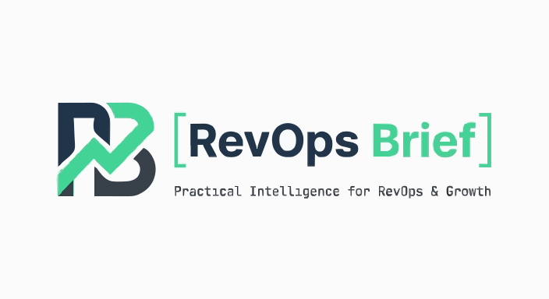
REVOPS BRIEF · FIELD GUIDE SERIES · 2026 EDITION
Martech
Evaluation
Checklist

72 questions every RevOps professional must answer before signing.
Covering: Vendor Evaluation · Integration Readiness · Data Model Impact · TCO Estimation
72 Items  Total Checklist Points | 4 Domains  Coverage Areas | 3 Priorities  Critical / High / Medium | 3-Year  TCO Horizon
Prepared for RevOps & GTM Leaders
Version 4.0 · 2026 Edition

How to Use This Checklist
If you've been burned by a martech purchase that looked flawless in the demo and then turned into a two-year headache — this checklist is your insurance policy. And if you've inherited a stack that nobody actually evaluated properly, and you're the one living with the fallout? This is how you make sure it doesn't happen again.
This isn't a feature comparison matrix. Feature matrices are what vendors hand you to compare themselves favourably against each other. This is the list of questions they don't especially want you asking — because honest answers sometimes kill the deal. And sometimes they should.
The 72 items here span four domains. Work through them in order. But don't skip the sections that feel less exciting. Integration readiness and data model impact — the boring bits — are where most martech failures actually start. By the time you're doing an emergency data migration 18 months later, the damage from items 21 through 55 was done the day you signed.
A note on the 2026 context: the landscape has shifted materially since previous editions of this checklist. AI-native tools now constitute a third of new martech category entrants, bringing genuine capability — and genuine new risks around data training rights, model governance, and output auditability. The consolidation wave that began in 2022 has produced a smaller number of better-funded category leaders, and a long tail of underfunded point solutions that look healthy on the surface. The questions in this document are designed to surface both.
(One more thing before you start: this checklist will occasionally feel like overkill. Some items will seem paranoid for a tool you're only spending £15K a year on. Do them anyway. The £15K tool that breaks your CRM sync is not a £15K problem.)

Priority Framework
Each checklist item carries a priority designation. Use these to triage when time is limited — but understand that "medium priority" does not mean "optional." It means the failure mode is slower, not absent.
⬛ CRITICAL | A red flag or gap here is a blocker. Do not proceed to contract without a clear, documented resolution. These items represent existential risks to your implementation, your compliance posture, or your data integrity. In 2026, several of the AI governance and data residency items newly carry this designation.
⬛ HIGH | A gap here will create material operational problems within 6–12 months. Mitigations must be contractually documented before signing. These are not theoretical risks — they are patterns that appear repeatedly in post-implementation reviews.
⬛ MEDIUM | Important for long-term success and operational maturity. Gaps are manageable with documented workarounds in the short term, but should inform your implementation roadmap and be addressed within 6 months of go-live.

Scoring & Decision Framework
Score each item on a 0–2 scale: 0 = Not met, 1 = Partially met or mitigated, 2 = Fully met. A maximum of 144 points is possible across the full checklist. Use the table below to make sense of where you land.
Score | Rating | Action Required
90 – 100% | Green — Proceed | Minor diligence items remain. Document them, assign owners, and move to contract. You're in good shape.
75 – 89% | Amber — Conditions Apply | Negotiate SLA improvements and get a written remediation plan before signing. Don't rely on verbal commitments.
60 – 74% | Orange — Serious Caution | Significant gaps across multiple domains. A structured pilot is required before any multi-year commitment.
Below 60% | Red — Do Not Proceed | Fundamental misalignment. Re-evaluate the category or re-scope the use case before re-engaging any vendor.

"The best martech decision you can make is the one you can still explain to your CFO three years later. Everything else is just wishful thinking with a purchase order attached."

A Note on Human Judgment
No checklist replaces judgment. You'll meet vendors who score imperfectly on paper but who have the kind of strategic alignment, team quality, and genuine partnership mindset that outweighs the gaps. And you'll meet vendors who tick every box but whose culture and responsiveness tell a different story entirely.
Use this checklist as the floor of your evaluation, not the ceiling. The conversations it generates — internally and with the vendor — are often more valuable than the scores themselves. A vendor who gets defensive when you ask about data portability is telling you something. A vendor who hands you a reference list without you asking is also telling you something.
The best RevOps people I know treat vendor evaluations the way a good hiring manager treats interviews: structured enough to be fair, open enough to catch what the structure misses, and always paying attention to what the data isn't showing them.

SECTION 1: VENDOR EVALUATION

1. Vendor Evaluation

Items 01–20 · Maximum 40 Points
This is where most evaluations spend too little time. Everyone's busy staring at the product — the interface, the features, the little integration logos on the marketing page. But you're not buying a product. You're entering a business relationship with a company. And that company's financial health, culture, and strategic direction will shape your day-to-day experience of the product far more than any single feature will.
I've watched teams build their entire RevOps architecture on a vendor that got acquired six months later and sunset two years after that. I've seen "best-in-class" tools propped up by a support team of four people managing 60,000 customers. The vendor evaluation isn't box-ticking. It's the foundation everything else sits on. Get it wrong here and no amount of brilliant implementation will save you.

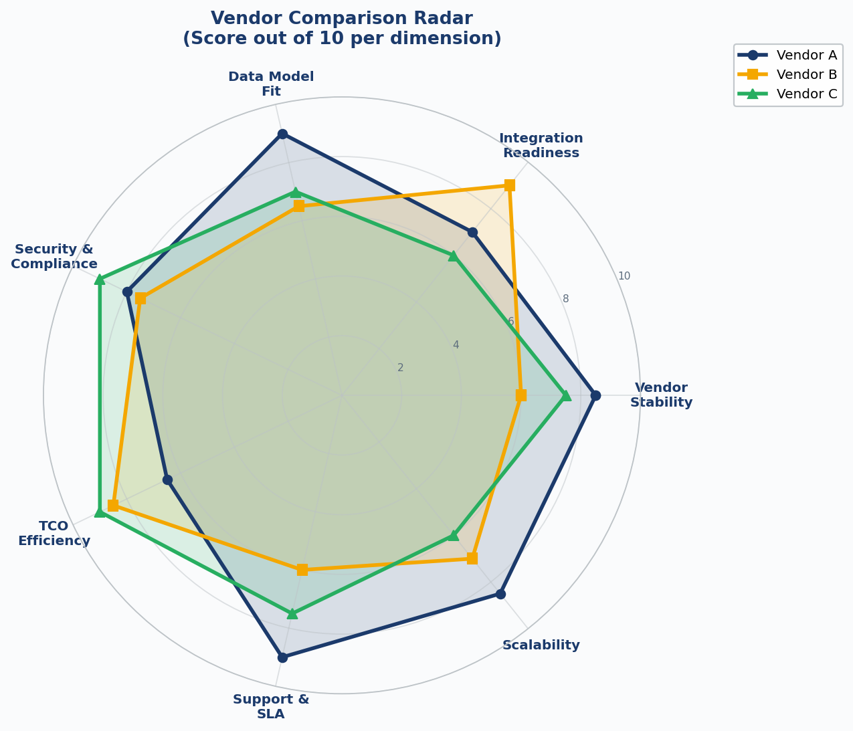
Figure 1: Vendor Comparison Radar — evaluate across seven strategic dimensions before comparing feature sets

01 | ☐ | Company Financial Health & Funding Runway ⬛ CRITICAL
 |  | Ask for the vendor's most recent audited financials — or, for private companies, a straight conversation about funding stage, burn rate, and runway. A vendor that goes under mid-contract doesn't just leave you stranded. It takes your data, your integrations, and your implementation investment with it. Look for at least 18 months of runway or demonstrated profitable operations. If they won't share anything, that itself is an answer.
02 | ☐ | Market Presence & Customer Reference Validation ⬛ CRITICAL
 |  | Talk to at least three current customers at similar company size, tech stack, and use-case maturity. G2, TrustRadius, and Gartner Peer Insights are a starting point — not the finish line. The most important question to ask every reference isn't "do you like it?" It's "would you buy it again, knowing what you know now?" And then: "What do you wish you'd known before you signed?"
03 | ☐ | Product Roadmap Transparency & Alignment ⬛ HIGH
 |  | Ask for a 12-month and 24-month roadmap. Pick the three features your team needs in the next year and confirm their placement. Then — and this is the bit most people skip — get it in writing as a contractual deliverable. Verbal commitments in a sales cycle are worth roughly nothing. If the vendor won't put it in the contract, assume it's aspirational, not a promise.
04 | ☐ | Contractual Flexibility: Exit Clauses & Data Portability ⬛ HIGH
 |  | Evaluate the exit process before you sign the entry. How long does data export take? In what format? Who actually owns the data? Many contracts bury 90-day notice periods and restrict export formats to proprietary ones nobody else can read. Make sure you can leave cleanly within 30 days with your full data in a standard format — CSV, JSON, Parquet. If you can't leave gracefully, you can't negotiate fairly.
05 | ☐ | Security Certifications & Compliance Posture ⬛ CRITICAL
 |  | Minimum acceptable baseline: SOC 2 Type II, ISO 27001, GDPR compliance, and a published breach notification policy. For B2B orgs with enterprise customers, add CCPA, HIPAA if applicable, and any vertical-specific standards. Ask for the most recent pen test summary and their mean time to remediate critical CVEs. A vendor who can't answer that last question promptly is a vendor who isn't measuring it.
06 | ☐ | SLA Architecture: Uptime, Degradation, and Remediation ⬛ HIGH
 |  | A 99.9% uptime SLA is 8.7 hours of acceptable downtime per year. Fine. But the more important questions are: what counts as downtime to this vendor — full outage, or degraded performance too? How do you claim credits, and are they automatic or manual? And what are the credits actually worth compared to the business cost of the outage? Read the SLA section of the contract before the commercial section. Most people do it the other way around.
07 | ☐ | Support Tier Structure & Escalation Paths ⬛ HIGH
 |  | Map out exactly what support comes with your contract tier. Premium support is usually an upsell, not a default. Know the difference between "email support with a 48-hour SLA" and "a dedicated CSM with phone access." For mission-critical tools, 24/7 live support should be a contractual commitment, not a verbal assurance from a sales rep who'll be gone in six months.
08 | ☐ | AI/ML Feature Maturity & Data Ethics Policy ⬛ MEDIUM
 |  | If the tool includes AI capabilities, you need to understand several things clearly: Is the model trained on shared customer data or isolated to yours? Do they retain the right to use your data to improve their models? Do they have a published AI ethics policy you can actually read and hold them to? In 2025 and into 2026, several vendors quietly updated their ToS to expand model training rights on customer data — often buried in a minor version update. Read the fine print every renewal cycle, not just at signing.
09 | ☐ | Acquisition Risk & Platform Consolidation Signals ⬛ HIGH
 |  | Research whether the vendor has recently been acquired, is in merger discussions, or is showing the classic signs of M&A positioning. Post-acquisition, roadmaps get frozen, key team members leave, and renewal negotiations shift in the vendor's favour. Check Crunchbase, LinkedIn headcount trends over 12 months, and PitchBook if you have access. Sudden spikes in executive hiring or an unusually quiet PR calendar can both be signals.
10 | ☐ | User Community & Ecosystem Health ⬛ MEDIUM
 |  | Spend ten minutes on their community forum before the next sales call. Not the homepage — the actual forum. A real community has messy questions, disagreements, workarounds, and answers from people who've been in the trenches. A hollow one has three posts from 2023 and a pinned message from the vendor saying "please reach out to support." That gap tells you something honest about how many people are actively using and advocating for this product. A healthy ecosystem of certified implementation partners matters too — it means there's enough demand to sustain a market around the tool.

"Vendor financial health isn't a nice-to-have diligence item. It's the most important variable in your 3-year total cost model. A vendor who goes bust or gets acqui-hired takes your implementation investment with them — and probably your data export timeline too."

11 | ☐ | Implementation Methodology & Time-to-Value Benchmarks ⬛ HIGH
 |  | Ask for the median time-to-value for companies your size — not the fastest case on record, the median. Then talk to reference customers who went live within the vendor's stated timeline and ask them what made it possible. Implementation overruns are the single biggest source of unplanned TCO in martech, and they are almost always attributed to underestimated complexity, not bad luck.
12 | ☐ | Training & Enablement Resource Quality ⬛ MEDIUM
 |  | Before the contract closes, spend 30 minutes in their knowledge base. Is it current? Are there video walkthroughs? Is there a certification programme that would actually help your team? The quality of self-serve documentation is one of the most reliable leading indicators of product maturity. Poor docs consistently signal one thing: you'll be paying for professional services to do things you should be able to do yourself.
13 | ☐ | Multi-tenancy & Enterprise Architecture Suitability ⬛ HIGH
 |  | If your org spans multiple business units, brands, or regions, confirm the product properly supports multi-instance or multi-tenant configurations. A surprising number of mid-market tools present as enterprise-ready in the sales cycle and then collapse the moment you need genuinely separate data environments, granular permission structures, or regional data residency. Ask for existing customers running multi-tenant configurations and talk to them directly.
14 | ☐ | Pricing Model Predictability & Scalability ⬛ MEDIUM
 |  | Map out every usage-based dimension in the pricing model: contacts, API calls, events, seats, workspaces. Then run your current volume and projected 2-year volume through the model. The question that matters most: what happens when you exceed the threshold? How much notice do you get before overage charges appear? "Automatic uplift" and "no notice required" in the same paragraph is a billing trap.
15 | ☐ | Data Ownership & Sub-processor Disclosure ⬛ CRITICAL
 |  | Get it confirmed in writing: you own your data at all times, full stop. Then request a current list of every sub-processor with their geographic locations. This is a GDPR requirement. It's also just basic hygiene. Any vendor who refuses to provide the list, or makes you sign a separate NDA just to see it, is a vendor you should think twice about handing your customer data to.
16 | ☐ | Product Release Cadence & Change Management ⬛ MEDIUM
 |  | A vendor who ships breaking changes with 24 hours' notice will destroy your internal operations repeatedly. Understand their release process before you're living with it: Do they offer release previews? A sandbox environment? A meaningful beta programme? The best vendors treat release cadence as a shared responsibility. The worst treat it as a surprise party your team has to scramble around.
17 | ☐ | Professional Services Dependency Risk ⬛ HIGH
 |  | Some vendors deliberately build in complexity to drive PS revenue. It's a real business model and you need to know if you're walking into it. Ask specifically: what percentage of customers at your size require ongoing PS to operate the platform? Can your team manage it independently after 6 months with proper onboarding? High PS dependency inflates TCO substantially and creates a single point of failure that never goes away.
18 | ☐ | Competitive Displacement Evidence & Win/Loss Data ⬛ MEDIUM
 |  | Ask the vendor who they most commonly replace and why. Then dig into the flip side: who wins when this vendor loses, and why? Honest vendors have good answers to both questions. The loss patterns are particularly revealing — they surface product limitations that will never appear in a demo. Research who has replaced this vendor in the past 12 months. G2 and community forums are useful here.
19 | ☐ | Executive Sponsor Alignment & Strategic Commitment ⬛ HIGH
 |  | Check whether the vendor is genuinely investing in your segment or quietly pivoting away from it. Sales reps come and go — get a commitment at VP or C-level, not just in conversation but in the account structure. Ask who will own your account post-close and what that person's book of accounts looks like. The answers are usually more revealing than anything in the deck.
20 | ☐ | Post-Sales Account Structure & QBR Cadence ⬛ MEDIUM
 |  | Find out who owns your account after the ink dries: is it the CSM who was in every pre-sales call, an account executive, or effectively a support queue? What's the QBR commitment in writing? The most common post-sales disappointment in martech isn't the product — it's the discovery that the excellent sales team has been replaced by an overloaded CSM managing 80 accounts across three time zones.

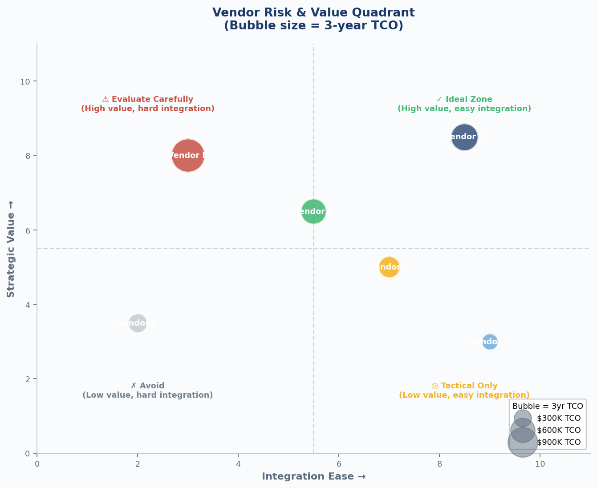
Figure 2: Vendor Risk & Value Quadrant — the ideal zone combines high strategic value with manageable integration complexity. Bubble size = 3-year TCO.

SECTION 2: INTEGRATION READINESS

2. Integration Readiness

Items 21–38 · Maximum 36 Points
Integration is where martech investments go to die slowly. It's unglamorous, it's technically messy, and it's almost universally underestimated. Every vendor will show you the logos of your favourite tools on their integrations page. What those logos rarely tell you: is this a real native integration or a Zapier connector dressed up in nice marketing? Does it sync in real time or once a day? Does it handle your custom objects, or just the standard ones Salesforce ships out of the box?
The questions in this section are designed to get beneath the integration marketing and into the engineering reality. Bring your technical team into these conversations. And if you don't have a technical person to do this with you, hire a consultant for this stage — seriously. One day of proper technical due diligence costs less than discovering a critical integration gap two months after go-live. Not even close.
(Yes, this means actually sitting down with a developer for two hours during the vendor evaluation. Yes, that's inconvenient. No, there's no shortcut that works as well.)

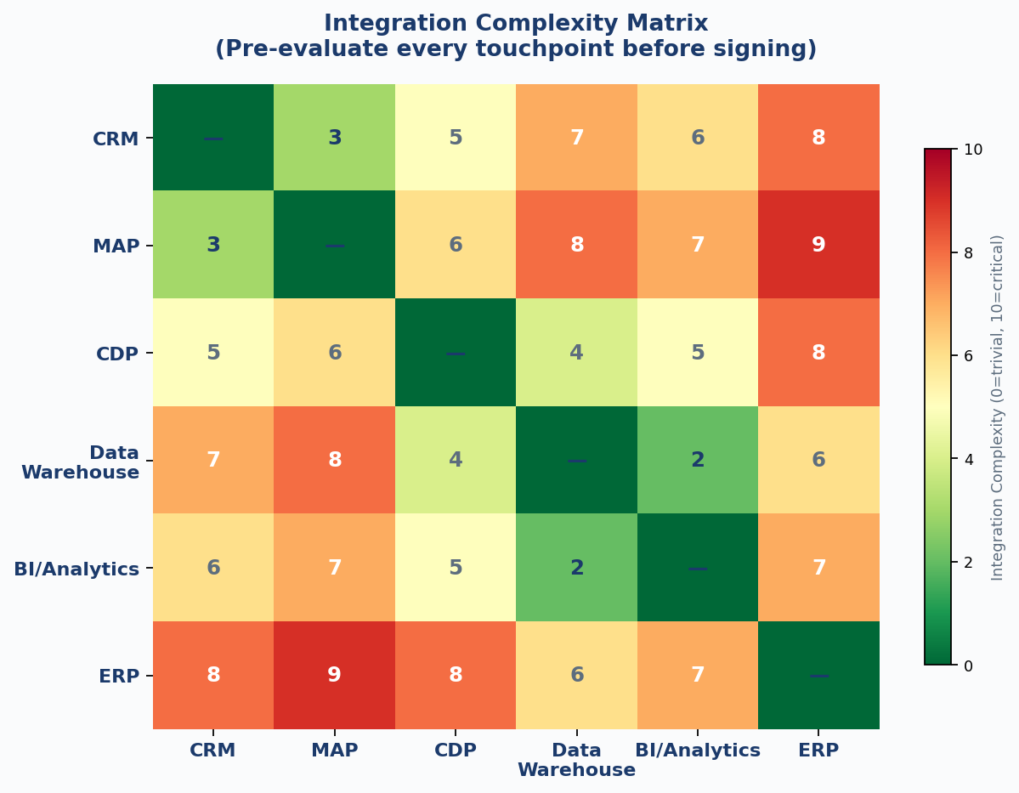
Figure 3: Integration Complexity Matrix — evaluate complexity across your existing tech stack before finalising any new vendor selection. Higher scores indicate greater integration risk.

21 | ☐ | Native CRM Integration Depth & Bi-Directionality ⬛ CRITICAL
 |  | A native connector that only syncs 40% of your CRM objects isn't a native integration — it's a partial sync with excellent marketing. Document every CRM object your team actively uses: Contacts, Accounts, Opportunities, Activities, Custom Objects. Verify each is supported with bi-directional, real-time or near-real-time sync. One-way sync creates data debt from day one, and it compounds.
22 | ☐ | API Architecture: REST vs GraphQL, Rate Limits & Versioning ⬛ CRITICAL
 |  | Get the actual rate limit numbers — burst limits and sustained limits — and stress-test them against your expected call volume at peak. Then ask about the API versioning policy: how long are deprecated versions supported before they're killed? Poor API versioning governance creates maintenance emergencies on a predictable 6–12 month cycle, and the fix always lands in the middle of something more important.
23 | ☐ | Webhook Reliability, Retry Logic & Failure Handling ⬛ HIGH
 |  | Here's the question most teams forget to ask: what happens when the webhook fails? Not if — when. Does the vendor retry on 5xx errors, and how many times before it gives up? Is there a dead-letter queue? A log you can actually audit? Silent webhook failures are the ghost data problems that haunt RevOps teams for months. They don't announce themselves. They just quietly corrupt your attribution data until someone notices the numbers don't add up and the finger-pointing starts.
24 | ☐ | iPaaS Compatibility: Native Connectors in Zapier, Make, Workato ⬛ HIGH
 |  | Look at the connector in your iPaaS marketplace and check the version, the last updated date, and customer reviews. A connector that hasn't been touched in three years isn't a current integration — it's technical debt waiting to break at an inconvenient moment. "We have a Zapier connector" means very different things depending on when that connector was last maintained.
25 | ☐ | ETL/ELT Pipeline Compatibility (Fivetran, Airbyte, dbt) ⬛ CRITICAL
 |  | If you run a modern data stack, verify the vendor has a maintained connector in your ETL/ELT tool of choice. Then check the schema change handling: when a new field appears in the source system, does it propagate downstream automatically, or does it silently break your pipeline? The latter is one of the most disruptive and least visible problems in a modern RevOps data architecture.
26 | ☐ | Event Streaming & Real-Time Data Architecture ⬛ HIGH
 |  | For high-velocity operations, verify whether the tool supports event-driven architecture via Kafka, Segment, or equivalent. Batch sync is fine for email campaigns. It doesn't work for real-time personalisation, in-app triggers, or time-sensitive sales alerts. Know which one you need before you buy, and make sure the vendor can actually deliver it — not just describe it in a deck.
27 | ☐ | SSO & Directory Sync (SAML, SCIM, OAuth2) ⬛ HIGH
 |  | Enterprise security makes SSO non-negotiable. Verify SAML 2.0 support for your IdP — Okta, Azure AD, Google Workspace — and confirm SCIM-based user provisioning and deprovisioning. Manual user management at scale is a compliance problem and a security exposure. Get SSO included in the contract tier you're signing, not added as a paid feature after the fact.
28 | ☐ | Data Warehouse & BI Tool Connectivity ⬛ MEDIUM
 |  | Verify connectivity to your data warehouse and BI tooling, whether native or via connector. But also understand the query pattern — does the tool push data outbound, or does it let you query the vendor's data model directly? The latter creates tight coupling that's very difficult to unpick later. Make sure your data engineering team has looked at this before you sign, not after.
29 | ☐ | Integration Maintenance Burden & Ownership Model ⬛ HIGH
 |  | When the vendor's API changes, who fixes the integration: you or them? How are you notified, and how far in advance? Every integration you own is a standing liability on your team's sprint capacity. Quantify the expected annual maintenance hours across your full integration surface area and include that number in your TCO model.

"Every integration you own is a maintenance liability on your team's sprint capacity — whether you've accounted for it or not. A five-integration stack can quietly consume 25% of a RevOps engineer's annual bandwidth just in upkeep. Model it before you commit."

30 | ☐ | Multi-Cloud & Hybrid Deployment Flexibility ⬛ MEDIUM
 |  | If your organisation has multi-cloud policies or infrastructure requirements, verify the tool supports your required cloud providers. Some tools are AWS-only. That creates infrastructure-layer vendor lock-in on top of the application-layer lock-in you're already taking on. Make sure your architecture team is in this conversation before you sign, not after.
31 | ☐ | Sandbox & Development Environment Parity ⬛ HIGH
 |  | Does the vendor provide a sandbox that mirrors production? Can you test integrations and configuration changes without touching live data? The absence of a proper sandbox means you're testing in production. It doesn't matter how confident the vendor is in their deployment process — the risk sits with you, not them.
32 | ☐ | Custom Object & Custom Field Propagation ⬛ MEDIUM
 |  | If you've built custom objects in your CRM or database — and most B2B teams have — verify the new tool can map to and sync these custom structures. Generic marketing tools often support standard objects beautifully and custom objects barely at all. This is the most common place B2B RevOps stacks break, and it's almost always discovered post-implementation.
33 | ☐ | Historical Data Migration Support ⬛ HIGH
 |  | Evaluate the vendor's documented process for importing historical data: how many years, what formats, is there a migration service or is it self-serve only? Historical data migration is consistently one of the most underestimated tasks in any martech transition. Budget for it to take three times longer than quoted. That's not pessimism — that's the historical average.
34 | ☐ | Integration Monitoring, Alerting & Observability ⬛ MEDIUM
 |  | Does the platform show you when something breaks, or do you find out when a sales rep calls? Those are your two options. Built-in integration health dashboards, sync failure alerts, and record count anomaly detection should be standard features, not premium add-ons. If you have to build your own monitoring layer on top of the tool just to know it's working, add that to your TCO.
35 | ☐ | API Authentication Security & Secrets Management ⬛ HIGH
 |  | Review API key rotation policies, OAuth token expiry, and IP allowlisting capabilities. Some legacy tools issue API keys that never expire and can't be scoped to specific endpoints — a significant security exposure. Best practice is short-lived tokens, per-integration scoping, and a full audit log of all API activity. If you can't audit it, you can't secure it.
36 | ☐ | Bulk Operations & Batch Processing Capacity ⬛ MEDIUM
 |  | Get the actual bulk API limits in writing: maximum batch size, concurrent job limits, and what happens when you hit the ceiling. For large data volumes — half a million records or more — rate limit throttling during bulk operations is a common and surprisingly undramatic cause of go-live delays. It doesn't crash anything, it just makes everything slower than projected until someone investigates.
37 | ☐ | Integration Documentation Quality & Developer Experience ⬛ MEDIUM
 |  | Spend 30 minutes with the developer documentation before the deal closes — not after. Is it current? Are there working code examples in languages your team uses? Is there an API explorer or a Postman collection? Poor developer docs are a reliable early signal of what implementation will feel like. The quality of documentation is a reflection of how much the vendor thinks about the person doing the work, not just the person making the decision.
38 | ☐ | Conflict Resolution Logic in Bi-Directional Syncs ⬛ HIGH
 |  | When both systems update the same record at the same time, which one wins? Most vendors have a simplistic "last write wins" rule that corrupts data in high-velocity environments without anyone noticing until the damage is done. For critical fields — revenue data, opportunity stage, contact owner — you should be able to define field-level precedence rules explicitly. If you can't, you're gambling with your data integrity.

SECTION 3: DATA MODEL IMPACT

3. Data Model Impact

Items 39–55 · Maximum 34 Points
Every tool you add to your stack either enriches your data model or quietly contaminates it. There's rarely a middle ground. A new MAP that creates duplicate person records doesn't just cause a mess in that tool — it propagates those duplicates across every connected system. A new CDP with a proprietary ID scheme creates a stitching problem that shows up in attribution reports, compliance audits, and sales forecasts all at once.
Data model impact assessment is the discipline of understanding — before you sign — exactly how this new tool will interact with the data structures your business depends on. It's painstaking. It requires knowledge of both your current stack and the vendor's schema. It's also one of the highest-leverage activities in the entire evaluation process. The teams who skip it are the ones rebuilding 18 months later because "the data got too messy." I've seen it more times than I can count.
The teams who do this properly find integration problems early — when they're cheap to fix, before contracts are signed and architects are committed. That's the point.
(I'll be honest: I have never once seen a team complete this section and wish they'd done less of it. The regret always runs the other direction.)

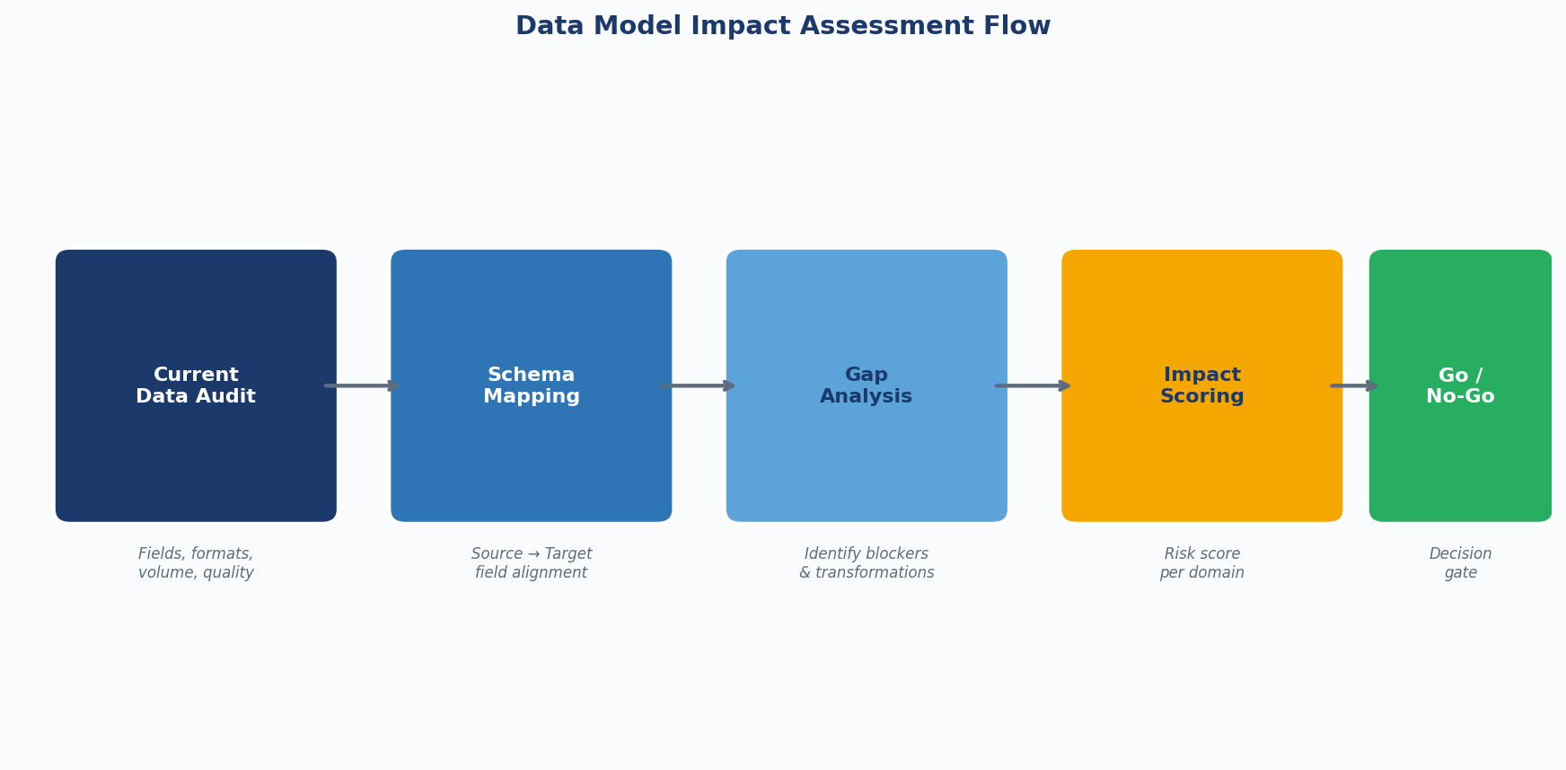
Figure 4: Data Model Impact Assessment Flow — run every new tool through this five-stage process before committing to integration design

39 | ☐ | Canonical Data Model Compatibility Assessment ⬛ CRITICAL
 |  | Before any technical work begins, map the vendor's data model against your canonical model. Identify the primary entities — Person, Company, Deal, Activity, Campaign, Event — and how the vendor structures each of them. Incompatibilities here don't stay contained. They require transformations at every integration layer, and those transformations compound in cost and complexity over the lifetime of the implementation.
40 | ☐ | Unique Identifier Strategy & Person Stitching ⬛ CRITICAL
 |  | How does this tool define a unique contact? By email? Phone? A proprietary ID? Mismatched identity resolution across your stack creates duplicate records, inflated contact counts, broken attribution, and compliance exposure simultaneously. Make sure the vendor's ID can be stored and referenced across your other systems — this is the thread that holds your data model together.
41 | ☐ | Handling of Duplicate Records & Deduplication Logic ⬛ HIGH
 |  | What does this tool do when it encounters two records for the same person? Does it merge them, flag them, or happily create a third one and carry on? Understand the merge strategy before you're in a situation where you need it: which record survives, what happens to historical activities, and can you review merges before they're applied or only after? Tools that accumulate duplicates without a clean resolution path are a data quality problem from their first week in production, not just eventually.
42 | ☐ | Field Type Fidelity & Data Type Mapping ⬛ HIGH
 |  | A datetime field that becomes a string in the destination system breaks every filter, sort, and report built on it — silently, until someone notices. Build a field-by-field mapping document. Validate every data type before you sign off on the integration design. It is genuinely tedious. Do it anyway.
43 | ☐ | Association & Relationship Model Complexity ⬛ HIGH
 |  | Can this tool accurately model the relationships your business actually runs on? In B2B: a Contact belongs to multiple Accounts, a Deal involves multiple Contacts, a Campaign touches multiple Deals. These aren't edge cases — they're standard B2B data structures. A flat model that can't handle them doesn't just limit your reporting. It forces workarounds that calcify into permanent technical debt and gradually make your data architecture harder to reason about for everyone who inherits it.
44 | ☐ | Data Governance Framework & Field-Level Access Control ⬛ CRITICAL
 |  | Can you restrict specific fields to specific user roles? Can you mask PII from certain user segments? Role-based access at the object level only is frequently insufficient for organisations with real compliance requirements. Field-level security controls aren't a nice-to-have — for any tool touching personal or financial data, they're a baseline expectation.
45 | ☐ | Audit Trail & Record Change History ⬛ HIGH
 |  | For any tool touching revenue-critical data, verify it maintains a complete audit trail: who changed what, when, and from what previous value. This is a GDPR requirement for personal data, a SOX consideration for financial data, and a basic operational requirement for debugging production issues. Without it, you're investigating data problems in the dark and asking people to remember what they did three weeks ago.
46 | ☐ | Custom Field Limits & Schema Extensibility ⬛ MEDIUM
 |  | How many custom fields can you create per object? What types are supported? Some tools cap at 50 or 100 per object — which sounds like plenty until you're 18 months into a complex implementation with a mature data model. Always design for where your data model will be in two years, not where it is today. Asking this question later is a rebuild conversation.
47 | ☐ | Data Freshness & Staleness SLAs per Object Type ⬛ HIGH
 |  | What is the guaranteed sync frequency for each object type — not a blanket "syncs every hour" but per-object commitments? Some vendors sync Contacts hourly and Activities daily. Stale activity data breaks pipeline reviews, cadence triggers, and attribution models without any error message to tell you it's happening. Get specific SLAs per object type, in writing.

"Identity resolution is the foundation of your entire RevOps data model. One tool using email as the unique identifier and another using a proprietary ID will create a person duplication problem that compounds with every single record you process. Fix the philosophy before you build the plumbing."

48 | ☐ | GDPR Right to Erasure & Data Subject Request Handling ⬛ HIGH
 |  | When a contact submits a Right to Erasure request, can you delete or anonymise their data in this tool without breaking referential integrity across your connected systems? Erasure processes that take 90 days, or that orphan related records on deletion, are compliance failures. Understand the exact process and the exact timeline before you commit to a DPA that references this tool.
49 | ☐ | Data Residency & Cross-Border Transfer Compliance ⬛ MEDIUM
 |  | Get the specific cloud regions for data processing and storage confirmed in writing — not "EU-based" as a general assurance but actual region codes. For EU customers, verify data stays within EU borders or that SCCs are in place and referenced in the DPA. For global organisations, check whether residency can be enforced at the workspace or user level. Account-level only is frequently not granular enough for businesses with distinct regional operations, and the gap tends to surface during a compliance review rather than a sales call.
50 | ☐ | Schema Change Management & Backward Compatibility ⬛ HIGH
 |  | When you add a new field in a source system, does it automatically appear in the destination, or silently fail? When you rename a field, what happens to existing mappings? Schema change management is the least exciting part of RevOps architecture and one of the most common sources of production data incidents. Ask for specific examples of how the vendor has handled schema changes for existing customers.
51 | ☐ | Consent & Preference Data Model ⬛ MEDIUM
 |  | For marketing tools specifically, evaluate the consent data model in detail. Can you store granular consent records covering channel, purpose, timestamp, and source? Is the model designed to handle GDPR, CASL, CAN-SPAM, and the newer wave of US state privacy laws (VCDPA, CPA, CTDPA) simultaneously? A flat subscribed/unsubscribed binary field is not a compliant consent architecture in 2026 — regulators in multiple jurisdictions have made that abundantly clear, and enforcement is no longer theoretical.
52 | ☐ | Calculated Fields & Derived Metrics Architecture ⬛ MEDIUM
 |  | Can the tool calculate and store derived values dynamically — lead score, health score, days since last activity — based on related record data? Or do those calculations have to happen outside the platform and be written back in? It sounds like a small distinction. It isn't, once you're trying to trigger workflows or build reports on those values in real time.
53 | ☐ | Data Import Error Handling & Validation Rules ⬛ MEDIUM
 |  | When a data import fails, how does the tool communicate it? Field-level error reports are table stakes in mature platforms. A single "import failed" notification with no detail is not acceptable. Understand the validation rules engine: can you enforce required fields, format validation, and referential integrity at import time, before bad data gets into the system?
54 | ☐ | Cross-Object Reporting & Data Model Traversal ⬛ HIGH
 |  | Can you build reports that traverse across objects — Campaigns to Leads to Opportunities to Revenue — in a single query, without exporting to a spreadsheet in between? This multi-hop capability is the structural foundation of attribution modelling. Tools that silo reporting within single objects make it architecturally impossible to answer the questions RevOps exists to answer. Ask to see a live example during the demo, built on their data, not a pre-configured dashboard.
55 | ☐ | API-Exposed vs UI-Only Data Elements ⬛ MEDIUM
 |  | Some tools store data that's visible in the UI and inaccessible via API. List every field your team relies on and confirm each one's API status. UI-only fields can't be used in downstream automations, enrichment workflows, or reporting pipelines without a manual export in between. Manual exports always become bottlenecks.

SECTION 4: TCO ESTIMATION

4. Total Cost of Ownership

Items 56–72 · Maximum 34 Points
The licence fee is the smallest part of what this decision will actually cost you. I've seen teams sign a £30K/year tool and spend £200K building and maintaining the infrastructure around it. I've also seen proper enterprise platforms with £150K licence fees that, when implemented right, reduced the overall stack cost by 40% through genuine consolidation. Licence cost and total cost of ownership are related in the same way a restaurant menu price and your actual evening out are related — by the time you add drinks, service charge, and the cab home, you're in entirely different territory.
This section forces you to account for every cost element before you commit. The goal isn't to scare you out of the purchase. It's to make sure your business case is built on reality, not on the optimistic assumptions that vendor ROI calculators are specifically engineered to produce.
A note specific to 2026: AI-native and AI-augmented tools have introduced a new class of pricing complexity — inference costs, token limits, model tiers, and "AI credits" that sit alongside or inside your licence. These are frequently opaque, scale non-linearly with usage, and are almost never included in the headline price. Every item in this section applies to AI-related costs with equal or greater force than it does to traditional SaaS pricing.

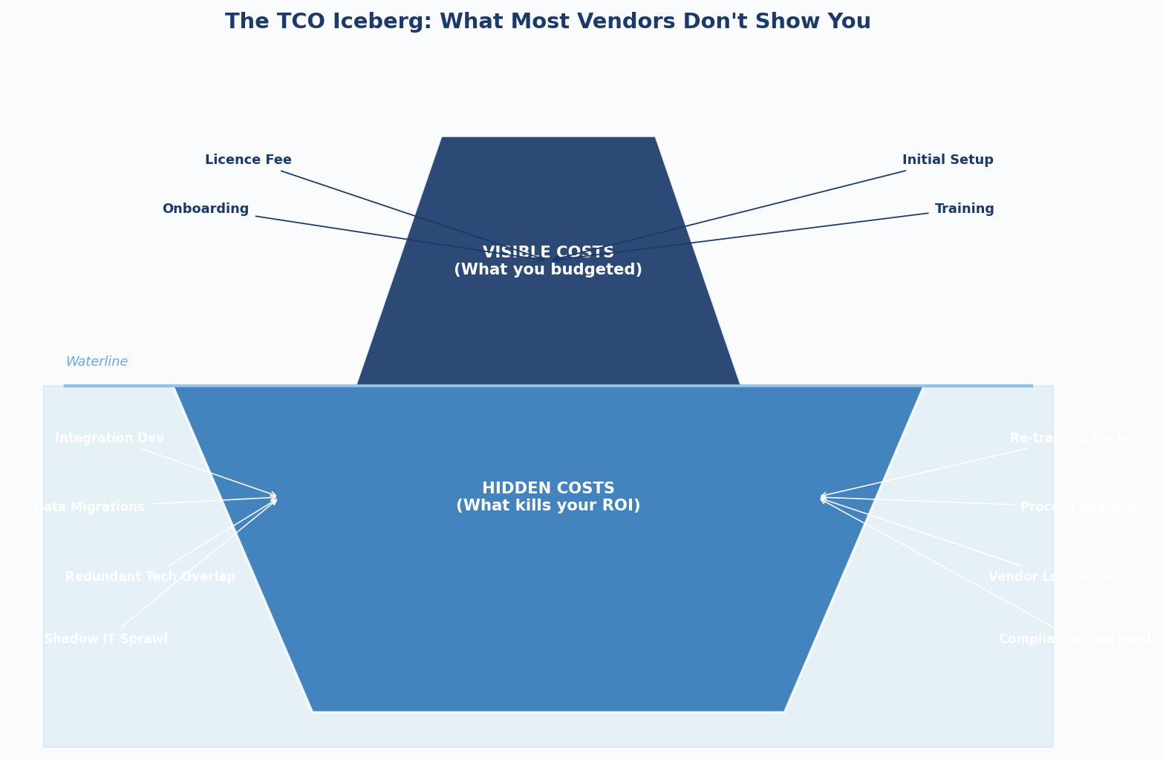
Figure 5: The TCO Iceberg — the costs above the waterline are what vendors quote. The costs below are what RevOps teams actually pay.

56 | ☐ | Year-1 Licence Cost Modelling Including All Variables ⬛ CRITICAL
 |  | Build a Year 1 cost model that captures every single pricing variable: base seats, power user seats, additional modules, API limits, storage overages, premium support tier, SSO add-ons, and anything else in the small print. Vendors advertise a base price that often bears no resemblance to what you'll actually pay. Get a fully itemised quote in writing — and compare it to what's in the contract, not just the deck.
57 | ☐ | 3-Year Licence Cost Escalation Modelling ⬛ CRITICAL
 |  | Negotiate and document the annual price escalation cap in the contract. 5–8% annual increases are normal. Uncapped escalation tied to some abstract "market rate" clause is not a deal you want to be in three years from now. Model your database growth against the pricing dimensions — tools priced per contact or per record can become exponentially expensive as your business scales, even at modest growth rates.
58 | ☐ | Implementation & Professional Services Cost Estimation ⬛ HIGH
 |  | Build a realistic PS cost estimate covering discovery, configuration, data migration, integration development, UAT, and hypercare. Get quotes from at least two implementation partners, not just the vendor's own PS team — their incentives are not the same as yours. Then add 30–40% contingency on top of the lowest number you receive. This isn't pessimism, it's what the data from real implementations consistently shows.
59 | ☐ | Internal Headcount Cost Attribution ⬛ HIGH
 |  | Quantify the internal resource cost of the implementation and ongoing operations. How many hours per week will your RevOps team spend managing this tool in steady state? At a fully-loaded cost of £80–120K per RevOps headcount, even 10 hours per week of tool management equals £20–40K annually. This number never appears in vendor TCO calculators. It absolutely should appear in yours.
60 | ☐ | Integration Development & Ongoing Maintenance Cost ⬛ HIGH
 |  | Estimate the engineering cost to build and maintain each integration across your stack. A single Salesforce to MAP integration built in-house can cost £15–30K in developer time and £5–10K annually to maintain. Multiply that across eight integrations and you have a material engineering investment that most technology evaluation frameworks don't account for at all.
61 | ☐ | Training & Change Management Cost ⬛ HIGH
 |  | Model the productivity dip during transition honestly. Twenty sales reps on a new tool for 60 days at 30% reduced productivity is a £50K+ opportunity cost — before you've spent anything on formal training. Add structured training costs (vendor certification, workshop facilitation, internal documentation) to get the real number. Most finance teams haven't seen this line in a business case before, which is exactly why it's worth putting it there.
62 | ☐ | Technology Overlap & Redundancy Cost Elimination ⬛ MEDIUM
 |  | Map every tool in your current stack that this new tool overlaps with. Then be honest: which subscriptions can you actually eliminate, and on what timeline? "Overlapping" tools often have functionality gaps that prevent clean elimination. Assume 6 months minimum for a clean deprecation in your model, and account for the dual-running cost during that period.
63 | ☐ | Contract Terms: Billing Cycle, Auto-Renewal & Notice Periods ⬛ HIGH
 |  | Read the billing section of the contract carefully. Annual vs. monthly billing differences can exceed 20%. Auto-renewal clauses that lock you in for another year with 30 days' notice are contractual traps — set a calendar reminder 90 days before every renewal. Know the vendor's fiscal year end and use it. The best pricing comes in Q4 when reps are chasing quota, not Q1 when they've already beaten it.
64 | ☐ | Opportunity Cost of Build vs. Buy Analysis ⬛ MEDIUM
 |  | For complex functionality, run a rigorous build vs. buy analysis. The hidden bias in build decisions is that engineers consistently underestimate ongoing maintenance cost. The hidden bias in buy decisions is that business teams consistently underestimate integration complexity. A structured framework that forces both sides to defend their numbers prevents some of the most expensive mistakes in RevOps.

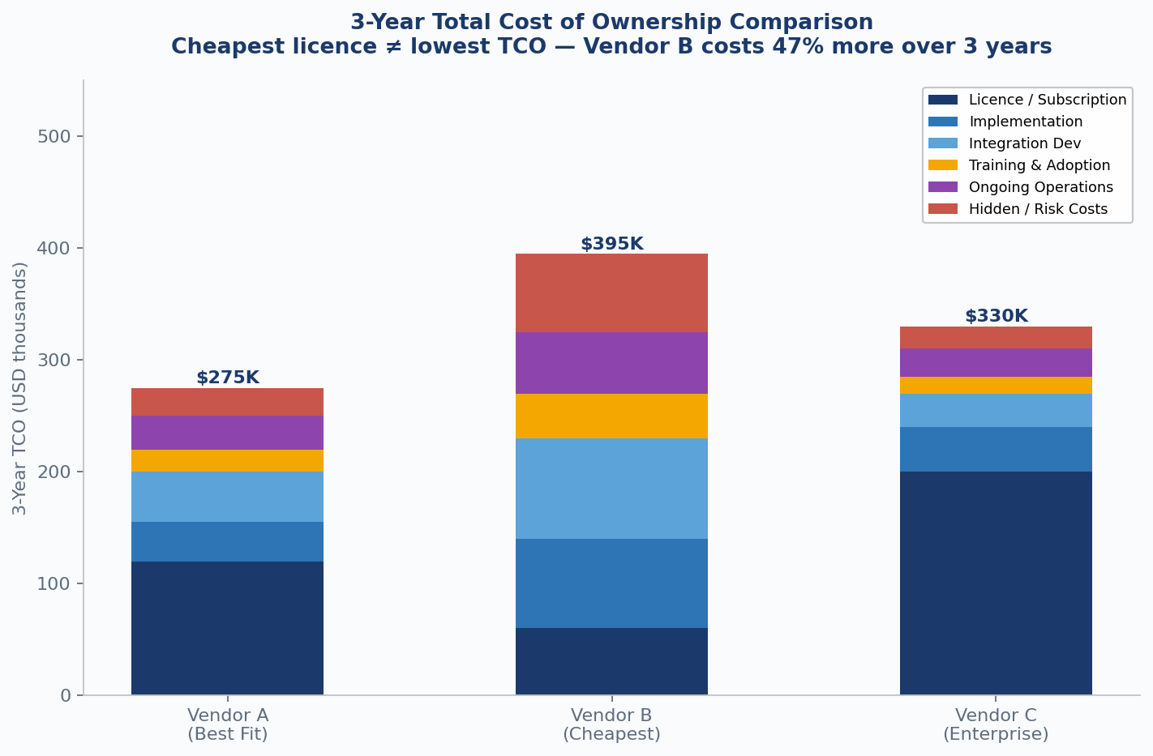
Figure 6: 3-Year TCO Comparison — the cheapest licence (Vendor B) costs 47% more over 3 years when all cost components are accounted for. Always model the full stack.

"I've never once seen a RevOps implementation come in under budget on the first attempt. The question isn't whether costs will exceed initial estimates — they will. The question is by how much, and whether your business case still holds at that number."

65 | ☐ | Migration & Offboarding Cost Estimation ⬛ HIGH
 |  | Even if you plan to use this tool indefinitely, model the cost of leaving. Data export, cleaning, and reimporting into a future system is expensive and time-consuming. The harder it is to leave, the more leverage the vendor holds in future renewals — and they know it. Ease of exit is a genuine evaluation criterion, not an afterthought. It directly affects how much power you have in the relationship.
66 | ☐ | Indirect Productivity Gains & Revenue Impact Modelling ⬛ MEDIUM
 |  | Build a first-principles model of the revenue impact: time saved per rep per week × average deal value × conversion rate improvement. Be conservative — genuinely conservative. Most vendors will give you case studies with 3x ROI. Discount those by 50% for your model. Credible, defensible ROI projections win internal budget approval. Inflated ones get shot down and damage your credibility for the next request.
67 | ☐ | Compliance & Legal Cost: DPA Negotiation, Legal Review ⬛ HIGH
 |  | Budget for legal review of the vendor's DPA, MSA, and security addenda before you start implementation planning. This is not optional if you process personal data. Enterprise DPA negotiations routinely take 6–8 weeks and involve real legal fees. Include it in your timeline from day one — not as a parallel track, but as a dependency that gates everything downstream.
68 | ☐ | Infrastructure & Hosting Cost Impact ⬛ MEDIUM
 |  | For tools with self-hosted or hybrid deployment options, model the full infrastructure cost: compute, storage, networking, monitoring, and backup. Cloud-hosted SaaS eliminates this overhead but at the cost of flexibility and data control. For on-premise or VPC deployments, infrastructure cost frequently exceeds licence cost in year one. Make sure finance understands which deployment model they're approving.
69 | ☐ | Vendor Price Lock & Enterprise Discount Negotiation ⬛ HIGH
 |  | Price lock periods are negotiable — push for a minimum two-year lock on multi-year contracts. Volume discounts are also negotiable, especially at fiscal year end. Know the vendor's financial calendar. The best pricing is almost never offered in Q1 when sales teams are fresh against new quotas. It's structured in Q4 or at the end of any quarter when reps are short of their number.
70 | ☐ | Risk-Adjusted ROI: Probability-Weighted Scenario Analysis ⬛ MEDIUM
 |  | Build three scenarios: Conservative (60% of projected benefits, 130% of projected costs), Base Case (100/100%), and Optimistic (130% benefits, 90% costs). Assign a probability to each and calculate the expected value. A purchase that only works in the optimistic scenario is a bet, not an investment. Present all three scenarios to your executive sponsor — the conversation that follows is usually more valuable than the model itself.
71 | ☐ | Benchmarking Against Category Peers ⬛ HIGH
 |  | Use analyst data from Gartner, Forrester, and community resources like RevOps Co-op and Pavilion to benchmark your proposed investment against peer companies of similar size and complexity. Overpaying by 25% relative to your peer set is a material budget problem that compounds at renewal. Underpaying sometimes signals a vendor in distress — both extremes are worth investigating.
72 | ☐ | Total Cost of Ownership Summary & Executive Sign-Off ⬛ CRITICAL
 |  | Pull every cost element together into a single TCO summary: Year 1, Year 2, Year 3. Licence, implementation, integration, training, internal headcount, compliance, risk — all of it in one place. Present it alongside projected ROI with honest confidence intervals. This is the document that gets the decision made. Write it for the person who is most sceptical about the purchase, not the person who is most excited about it.

APPENDIX A: EVALUATION SCORING SUMMARY

Appendix A: Scoring Summary Sheet
Use this to consolidate your scores across all four domains. Fill it out after working through the full checklist, not before. The temptation to skip to scores without doing the underlying diligence is real — resist it.
If a section feels hard to score, that's usually because the conversation hasn't happened yet. Go have it.

Domain | Items | Max Score | Your Score | % Score | RAG Status
1. Vendor Evaluation | 01–20 | 40 | ___ | ____% | 🟢 🟡 🔴
2. Integration Readiness | 21–38 | 36 | ___ | ____% | 🟢 🟡 🔴
3. Data Model Impact | 39–55 | 34 | ___ | ____% | 🟢 🟡 🔴
4. TCO Estimation | 56–72 | 34 | ___ | ____% | 🟢 🟡 🔴
TOTAL | 01–72 | 144 | ___ | ____% | 🟢 🟡 🔴

Critical Item Flag Register
Any CRITICAL item scored 0 must be documented here with a clear resolution plan and a named owner before the evaluation moves to contract phase. This isn't a formality — these are the items most likely to cause an implementation failure or land you in a compliance conversation you weren't expecting.

Item # | Item Title | Risk Description | Owner | Resolution Date

APPENDIX B: RED FLAGS & DEAL-BREAKERS

Appendix B: Red Flags — Walk Away Signals
Experience teaches you to read the room during vendor evaluations. Some red flags are obvious. Many aren't — they only become clear in hindsight, when you're already 10 months into an implementation wondering why you didn't notice them sooner. The list below comes from real evaluations: successful ones and catastrophic ones alike. No single flag is automatically a dealbreaker, but every one of them should trigger a real conversation with your team before you proceed.

Commercial Red Flags
- Vendor resists putting roadmap commitments in writing, citing "business agility" — a phrase that translates to "we're not confident we'll deliver this"
- SLA credits are capped at one month's licence fee regardless of downtime duration or business impact
- Data export is available only in proprietary formats or requires a professional services engagement to execute
- The quoted price changes materially after you share your actual data volumes or usage patterns
- Auto-renewal clause is buried in subsection 14.3 of a 40-page MSA — with a 30-day notice window. Set the calendar reminder now, before you forget
- Reference customers are all from different industries, different company sizes, or joined in the last 12 months
- Professional services are positioned as required for basic configuration that should be self-serve in a mature product
- The vendor recently raised a large round but when you look at where the headcount is growing, it's almost entirely in sales

Technical Red Flags — 2026 Edition
- API documentation was last meaningfully updated more than 18 months ago — a product that's moving should have docs that move with it
- No sandbox or staging environment — you're expected to test in production and "be careful"
- Bi-directional sync described in the pitch is actually a one-way sync plus a scheduled import you have to trigger manually
- Webhook failure handling is described as "best effort" with no retry logic, no dead-letter queue, and no audit log
- Custom objects are "supported with limitations" that are only disclosed after the contract is signed
- SSO is a paid add-on at the enterprise tier rather than a standard security feature
- AI features are built on third-party foundation models with no clarity on where your data goes during inference
- The most recent pen test report is more than 18 months old, or they won't share it even under NDA
- There is no published deprecation policy — breaking changes are communicated reactively, not proactively

Cultural & Operational Red Flags
- The sales cycle involves three AE handoffs with inconsistent messaging at each stage — a sign of an organisation that doesn't talk to itself
- Demo uses pre-built synthetic data that bears no resemblance to your use case, and they push back on a live demo with your own data
- Support response time during the evaluation is already slower than the advertised SLA — imagine what it looks like in month 14
- The CSM who was in every pre-sales call is not the person who will manage your account post-close
- Negative reviews on G2 and TrustRadius cluster around the same themes across multiple reviewers: billing surprises, support degradation post-acquisition, complexity that wasn't disclosed upfront. One bad review is noise. A pattern is signal.
- LinkedIn headcount data shows significant attrition in engineering and customer success over the past 6–12 months — look for it explicitly, because no vendor is going to mention it
- The vendor acquired a competitor in the past 18 months and when you ask about the integration roadmap, the answer is vague. Or enthusiastic but with no dates. Both are the same answer.

"The best vendors genuinely welcome tough questions. They have the answers ready because they've heard the questions before. The ones who deflect, stall, or escalate to legal the moment you ask about data portability? They're telling you something important about what year two of this relationship looks like."

APPENDIX C: CONTRACT NEGOTIATION GUIDE

Appendix C: What to Negotiate — Always
The initial contract a vendor sends you is written by their legal team, for their benefit. That's not a conspiracy — it's just how contracts work. Your job is to negotiate it into something that protects yours. The items below are the ones that make the most material difference in real-world implementations. None of them are unreasonable to ask for, and a vendor worth working with will negotiate most of them in good faith.

Pricing & Commercial Terms — 2026 Standards
Annual Price Escalation Cap | Push for a hard cap of 5% per year. If they insist on CPI-linked increases, define the specific measure and apply a ceiling of 7% absolute. In 2025–26, some vendors introduced "AI feature surcharges" as separate line items — ensure these are included in your escalation cap or excluded explicitly.
Volume Overage Policy | Negotiate a 30-day grace period and written notice before any overage charges apply. Avoid automatic invoice uplift. For AI-usage-based pricing specifically, require a hard spend cap before additional usage is billed.
Multi-Year Discount | Push for 15–20% discount on 2-year and 20–25% on 3-year commitments. Sign 1-year only if the vendor is pre-Series B, recently acquired, or in an uncertain category position — all of which apply to a significant portion of the current market.
Exit Penalty Caps | Cap termination fees at a maximum of 3 months' equivalent licence value. No penalty for exit due to vendor breach, material service degradation, or failure to deliver contractually committed roadmap items.
Implementation Credit | Request PS credits equal to 10–15% of first-year contract value. This is standard in enterprise deals. If they push back hard, treat it as a signal about how they approach partnership vs. extraction.

Legal & Compliance Terms
Data Portability Clause | Explicit right to export all data in CSV, JSON, or Parquet format within 30 days of contract termination notice. Vendor to provide export documentation and reasonable assistance at no additional cost. In 2026, also specify rights to export AI-generated outputs, enrichment data, and model configurations where applicable.
AI Data Usage Rights | New for 2026: explicitly state that the vendor may not use your data to train, fine-tune, or improve any AI or ML model — whether internal or third-party — without prior written consent. Blanket ToS clauses granting model training rights are increasingly common and should be explicitly overridden in the MSA.
Sub-processor List | Right to receive an updated sub-processor list within 48 hours of any change. Right to object within 30 days. Pay particular attention to AI infrastructure sub-processors (LLM providers, GPU cloud vendors) — these are frequently omitted from standard lists.
Breach Notification | Mandatory notification within 24 hours of discovery of any breach involving your data. Include a named contact and escalation path. Under the EU's updated enforcement posture in 2025–26, 72-hour notification to regulators is required — your vendor's 24-hour commitment to you needs to sit comfortably inside that window.
Audit Rights | Right to audit or commission a third-party audit of vendor security controls once per year with 30 days' notice. If the vendor offers a shared SOC 2 Type II report, confirm it covers the specific services you're purchasing and was issued within the last 12 months.

Technical & Operational Terms
API Rate Limit Guarantee | Document committed rate limits in the contract, not just the published limits page which can change without notice. For AI-powered features with inference costs, define the usage model and rate limits separately from standard API limits.
Deprecation Notice Period | Minimum 180-day notice for API endpoint deprecation and 90-day notice for feature deprecation. In fast-moving AI product areas, push for 12 months — vendors shipping AI features in beta often deprecate them without warning.
Roadmap Commitments | Any feature critical to your business case listed as a contractual deliverable with a specific quarter commitment and a documented remedy. This matters more in 2026 than ever — AI capability claims in sales cycles are frequently aspirational rather than delivered.
Support Tier in Contract | The support tier must be specified in the MSA, not just the order form. "Premium Support" means nothing without a definition. Define response time SLAs, escalation contacts, and whether AI-powered support tools can be used in lieu of human response (and whether that counts toward SLA compliance).
Data Residency | Specify the exact cloud regions for data processing and storage. In 2026, also specify the regions used for AI inference if the tool uses LLMs for any functionality — inference can involve data transmission across regions that fall outside your DPA scope if not explicitly addressed.

CLOSING NOTE

A Final Word
The RevOps function exists to make go-to-market operations work better — cleaner data, faster processes, more predictable revenue. The martech stack is the infrastructure that either enables that mission or quietly undermines it. Every tool you add either simplifies the environment your team operates in, or complicates it. There's no neutral.
The 72 items here aren't designed to make vendor evaluations slower. They're designed to make them more honest — with the vendor and with yourselves. The questions you skip in the evaluation phase become the problems you manage in the operations phase. And operations problems are always more expensive than evaluation thoroughness. Always.
The best martech decisions I've seen share a common trait: they were made by teams who were brutally honest about what they needed, what they could afford, and what their organisation could actually implement. Not what they wished they needed. Not what the sales rep said they needed. What they actually needed, right now, given their data, their team, and their 12-month reality.
Use this checklist in that spirit. Push back on vendors who can't give you straight answers. Push back on your own assumptions when you catch yourself rationalising a gap. The market will always offer you another vendor who can solve the problem you're trying to solve.
What the market won't offer you is a way to get back the 18 months you'll spend undoing a bad decision. Nobody gets a refund on that.

Good luck. And remember: the demo is not the product.

Published by  www.revopsbrief.com | Questions? Feedback? Want to contribute?  Contact us  signals@revopsbrief.com  For redistribution with attribution only.

